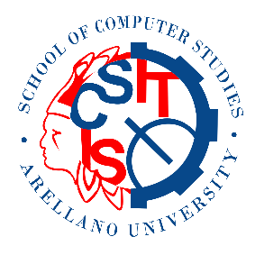**School of Computer Studies Student Society**

Arellano University Jose Abad Santos Campus

3058 Taft Ave, Pasay, Metro Manila

15 January 2020

**Black Knight Philippines**

Parañaque, Metro Manila

Philippines

To whom it may concern,

The School of Computer Studies Student Society (SCS-SS) together with the Senior High School from ICT Strand will hold its yearly departmental week, with the Theme: **TEAM (Technology in Education is Always a Motivation)** on the 19-22 of February 2020 at Arellano University – Jose Abad Santos Campus, 3058 Taft Avenue, Pasay City. The School of Computer Studies Student Society is having the following activities:

**Academic Activities:**

1. Programming Competition
2. Quiz Bee
3. Computer Disassembly and Assembly
4. Networking Competition

**Sport Activities;**

1. Basketball
2. Volleyball
3. Badminton

**Others:**

1. Mobile Legends Tournament

**Miscellaneous:**

1. Sounds
2. Refreshments
3. Trophies and Certificates
4. Giveaway/ Tokens

In connection to this, the School of Computer Studies Student Society would like to ask for help from companies and corporations like yours to provide **10 tubes of SHUTTLECOCKS** that will be used on the Badminton matches on the event or help us achieve the 40,000php fund to make this event more possible. Attached are the different list of products that you may also help us with for your evaluation. Your help would be highly appreciated in achieving our goal of promoting sportsmanship between students and showcasing the student’s knowledge through friendly competition in the event.

We would be featuring your company name in all our ads and posters for the event and as such would surely provide added positive publicity for your company. For additional questions and clarifications, please don’t hesitate to call me through the contact information provided below.

Thank you in advance for your sponsorship support for SCS-SS Week – TEAM, **Technology in Education is Always a Motivation**. We look forward to seeing you.

Sincerely,

___________________

**Rodel B. Campang**

President, SCS-SS

0917-6305255

Noted by:

___________________ ___________________

**Mr. Orlando Bernaldez** **Mr. Melchor Erise**

Adviser, SCS-SS Program Chair, SCS

You may also choose to be a provider of any items listed below. The items that you will provide may contain your company name and/or logo. You will also receive proper acknowledgement during the program.

Items Details

Black Knight Lanyards for giveaway For students present in the event – 300pcs

Black Knight Pens for giveaway For students present in the event – 300pcs

Black Knight Badminton Bags for raffle Between students in the event – 5pcs